Equidistant from a point
Can you find all the points which are 2km away from the school?
The locus of points that are equal distance from a point form a ………..
Locus=

Locus of points equidistant from an object
Abdul wants to make a gravel path that is exactly 1m thick all the way around the edge of the house. Draw the locus of points which would mark the edge of the 1m path.
The locus of the points equidistant from an object are ……………….
Locus of points equidistant from two points

A house is exactly the same distance from water tap A and water tap B.
Draw the locus of points which represents where the house could be.

The locus of points equidistant from two fixed points is ………..

The lines is at …………to the line which joins up your two fixed points (the line AB) and ……………. between them.

It is the …………….. of the line AB.

Constructing a perpendicular bisector

Example: construct the perpendicular bisector of the line AB

Practice: construct the perpendicular bisectors of the following.

1) The line AB

2) The points A and B

The locus of points that are equidistant from two lines
Mary wants to plant her tree so that it's exactly half way between the two walls of her garden so that it can get the most sunlight. Find the locus of points where Mary could plant her tree.
The locus of points equidistant from two lines is ………..
It cuts the angle that the two lines from in half- we call it an ……………..

Constructing an angle bisector
Example: construct the angle bisector of the angle ABC

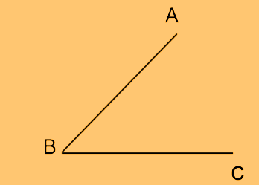

Practice: constructing an angle bisector
Construct the angle bisector of the following angles

The shortest distance between a point and a line
A road is to be constructed from a school to the road. The school would like the road to be as short as possible so that the journey to the school can be as quick as possible.
How could we find the shortest possible road?
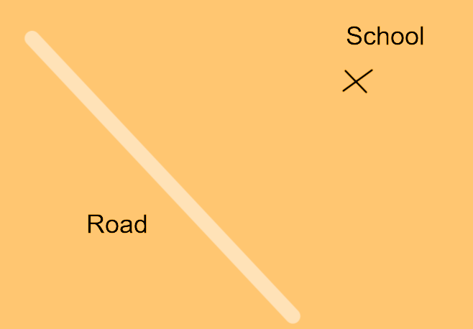
Constructing the ……………………………… would find us the shortest possible route.

Constructing the perpendicular from a point to a line

Practice: constructing the perpendicular from a point to a line
1) Draw the perpendicular from the point to the line
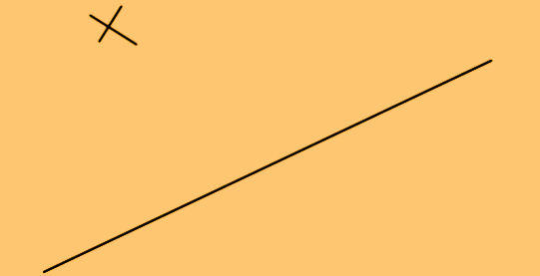

2) Find the shortest distance between point A and the line BC
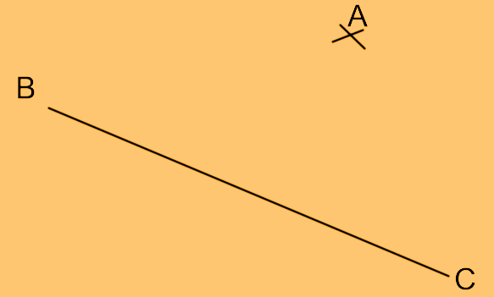

Drawing a perpendicular from a line at a point
Tom wants to construct a garden path which forms a right angle with his current garden path and crosses his path at the point where his frog path stone sits (marked with a cross).
Draw on the diagram where Tom's new path should go.
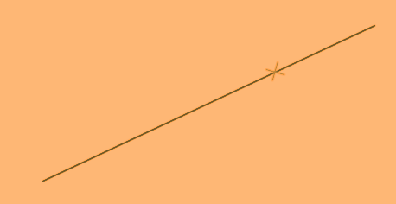
The new path is perpendicular to the line but is not the perpendicular bisector as……………………… ………………………..
Constructing the perpendicular to a line through a point

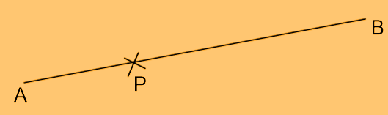

Practice: constructing a perpendicular from a line at a point
1) Construct the perpendicular to the line segment AB which passes through the point G.

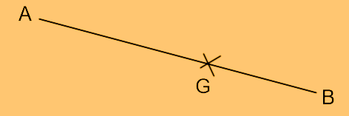

2) Construct the line which forms a right angle with the line AB and passes through the point H.

