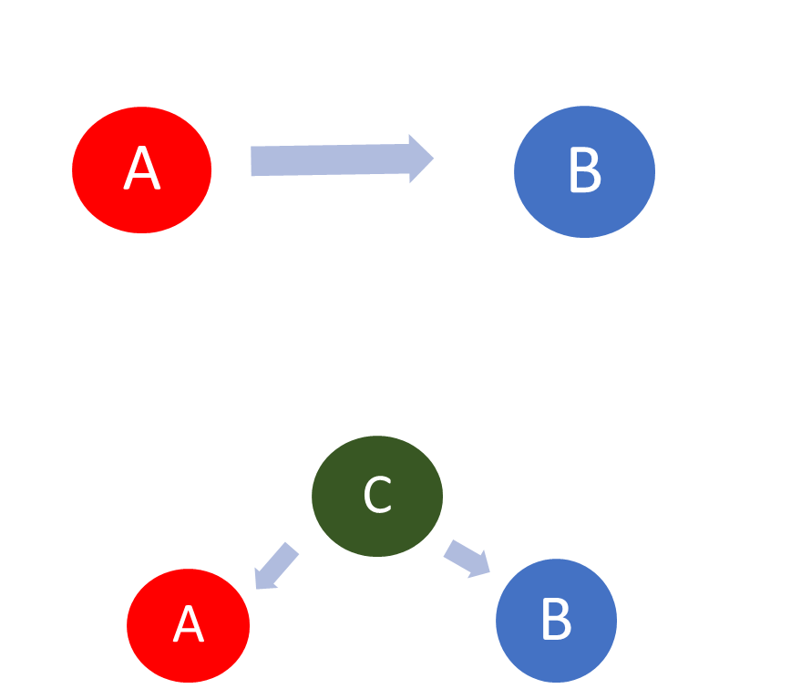
Thinking Like a Scientist; Links (correlations) and Causes.
It is important to learn that links can point to important evidence of what causes something.
However we need to think carefully and check that there is not another thing which is causing the link we can see.
For each example think carefully about whether A causes B or whether you can think of another thing, lets call it C, which could cause a change in both A and B.

Example | Can you think of another reason (C) which would cause the link between A and B?
A Children’s shoe size is linked to B their reading ability, the bigger the shoe size the higher the reading ability.

A The number of ice creams sales is linked to B deaths by drowning the higher the number of ice creams sold, the higher the number of drownings.

Since the 1950s, both A the atmospheric CO₂ level and B obesity levels, have increased sharply.

Since the industrial revolution both A the atmospheric CO₂ level and B global temperatures, have increased.

