1.The Intergovernmental Panel on Climate Change (IPCC) is part of the United Nations. It looks at scientific evidence about climate change and writes reports. The IPCC is made up of scientists, people from industry and organisations which are separate from governments (NGOs). It has both men and women and draws on people from all regions of the world, representing both developed and developing countries. They work together to produce a report which everyone on the IPCC agrees with. This is called making decisions by consensus. In their 5th report the IPCC stated that “It is extremely likely that human activities caused more than half of the observed increase in temperatures (GMST) from 1951 to 2010” and “It is virtually certain that internal variability (natural fluctuations) alone cannot account for the observed global warming since 1951”. | 2. Using many methods, scientists have agreed that global sea level (the average height of the sea surface across the planet ) has gone up throughout history, especially in response to the ice ages.  In recent history, starting around 7,000 years ago, sea level became quite steady, but over the last century, it’s been rising.
3
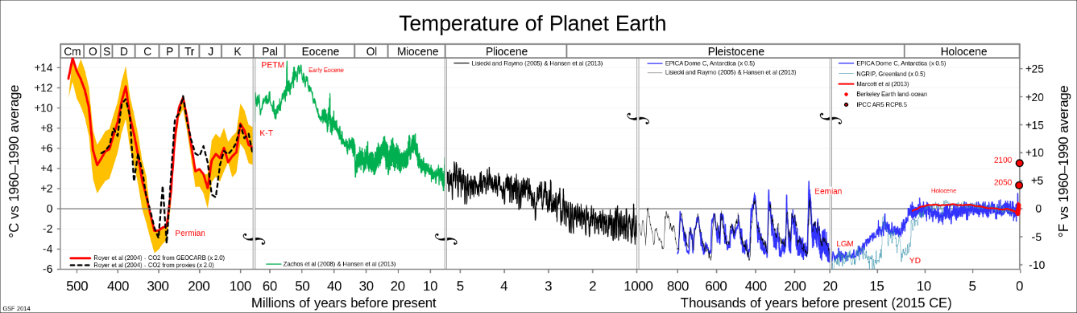
Author Glen Fergus https://en.wikipedia.org/wiki/Geologic_temperature_record

4  Carbon dioxide levels are at their highest in 650,000 years. | 5  18 of the warmest 19 years on record have happened since 2001.
6 Area of arctic sea ice | 7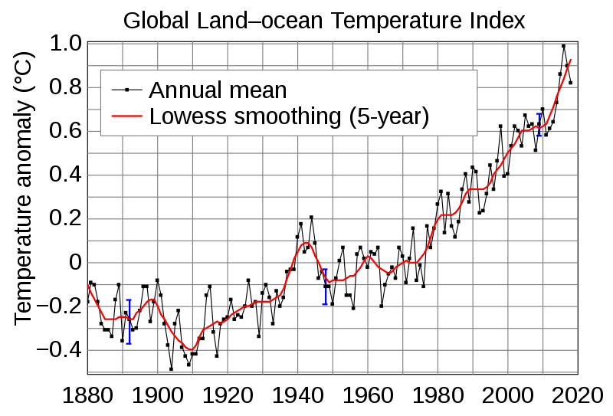  The graph shows the global temperature each year compared to an average of the temperatures measured between 1950 and 1980.  https://en.wikipedia.org/wiki/Global_temperature_record Source: NASA GISS
year | Million sq km
1980 | 7.90
1990 | 6.30
2000 | 6.40
2010 | 4.90

Source NASA https://climate.nasa.gov/vital-signs/arctic-sea-ice/
8 Sea level changes  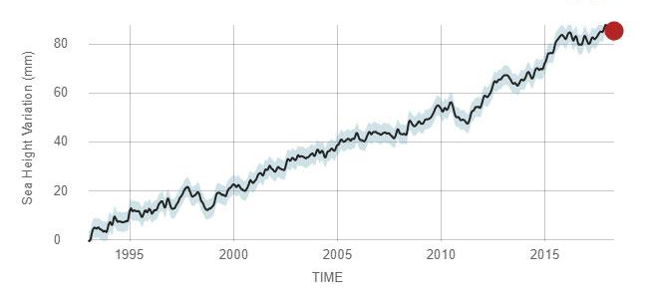  By NASA - https://climate.nasa.gov/vital-signs/sea-level/, Public Domain, https://commons.wikimedia.org/w/index.php?curid=71578292 | 9 World population growth  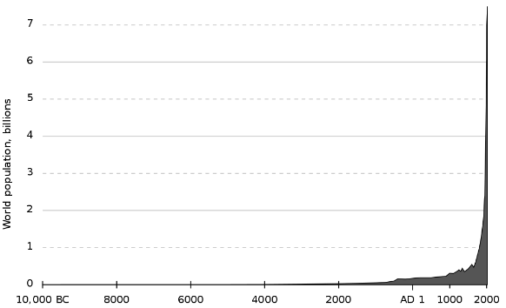  https://en.wikipedia.org/wiki/World_population
10

