Initial ideas
- Where do animals get their food?  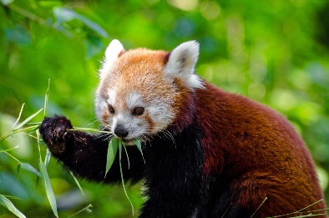 | - Where do plants get their food?  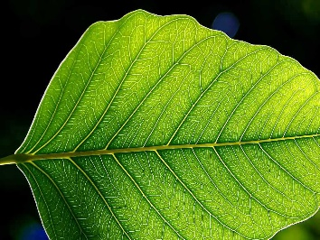
- Where does the mass of an animal come from?  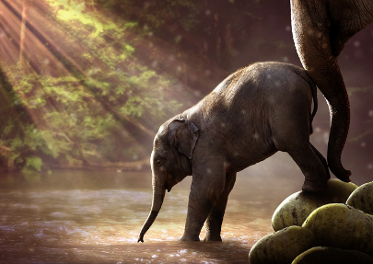 | - Where does the mass of a plant come from?  

