Check your understanding of gas exchange in the lungs.
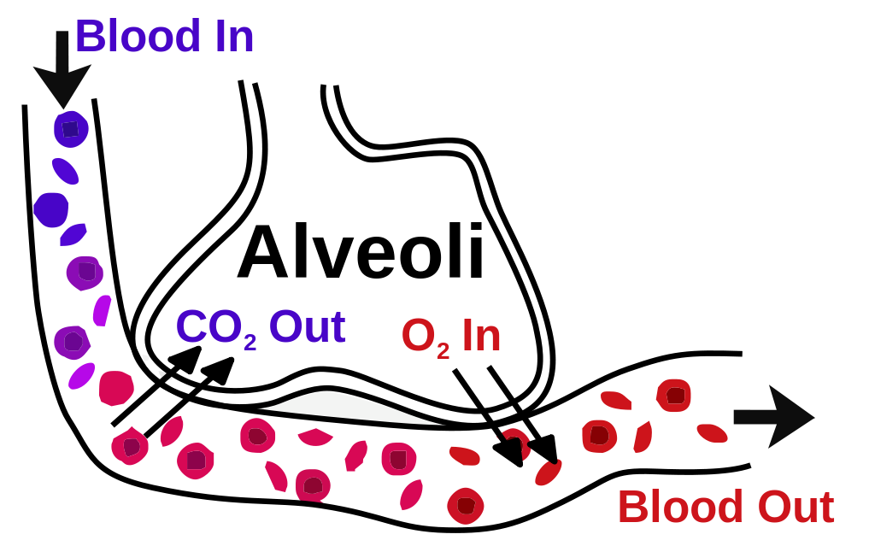

Blood entering the lungs has a high concentration of ________________
Air entering the lungs has a high concentration of ___________________
Carbon dioxide moves from the blood to the _______________________
Oxygen moves from the alveoli to the _____________________________
The air leaving the lungs has a lowered concentration of ______________
The blood leaving the lungs has a lowered concentration of _______________

