Interpreting Deforestation Graphs ANSWERS
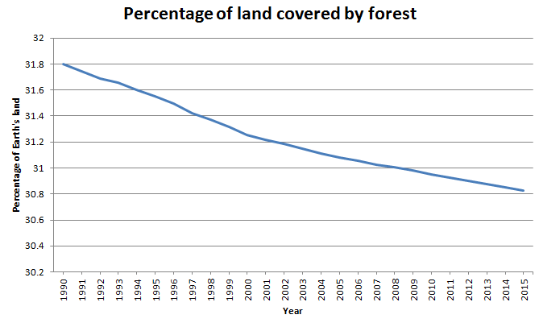
What percentage of the Earth’s land was covered with forest in 1995? 31.8%
What percentage of the Earth’s land was covered with forest in 2015? 30.8%
What percentage of Earth’s land was deforested between 1990 and 2015? Approximately 1%
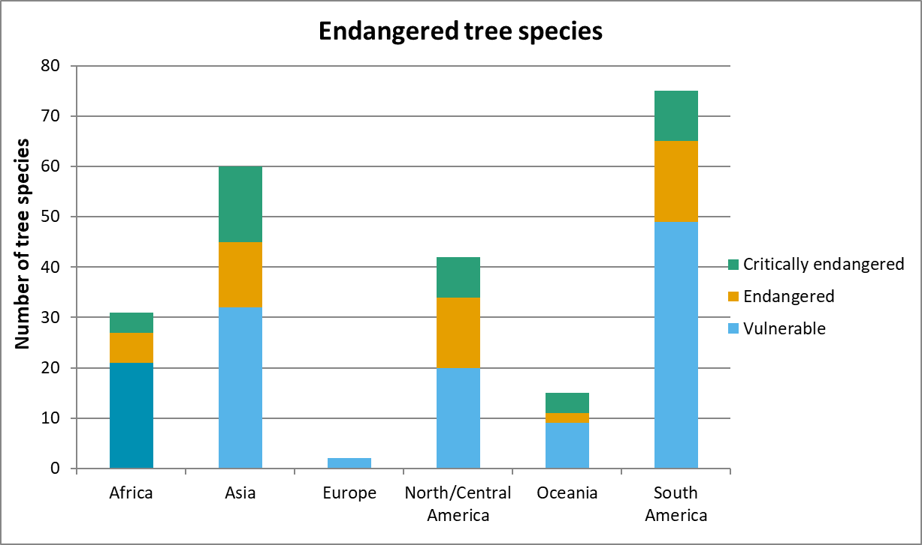
Which continent has the highest number of trees that are listed as in danger? South America
How many tree species are classed as endangered in Africa? 6 (this is from the original data, so your answer from reading the graph may be slightly different)
How many tree species are officially classed as critically endangered in the world? 4+15+8+4+10 = 41 (your answer may be slightly different)
What is causing tree species to be endangered? Deforestation.
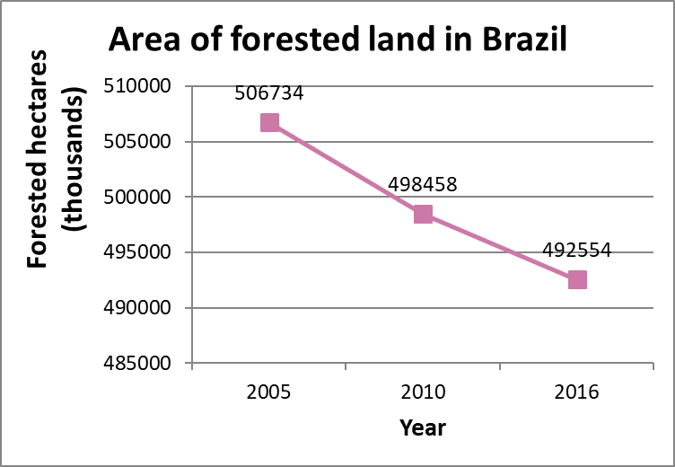
In what way could this graph mislead the viewer? (there are two main ways, plus one sneaky answer)
The use of thousands in the axis label means that the viewer might not notice the magnitude (they might think there are 506,734 hectares of forest in 2005, rather than 506,734,000 hectares)
The axis doesn’t start from 0, so the extent of deforestation is exaggerated. It looks as though the amount of forest almost halved between 2005 and 2010, but that is not true.
The sneaky answer: The years are not correctly spaced on the horizontal axis. There is 5 years between 2005 and 2010, but 6 years between 2010 and 2016, so technically the third category should be slightly further to the right.
Brazil has a total area of 835,814,000 hectares. What percentage was forested in 2005?
506,734,000 ÷ 835,814,000 x 100 = 60.63% (to two decimal places)
What percentage of Brazil was forested in 2016?
492,554,000 ÷ 835,814,000 x 100 = 58.93% (to two decimal places)
Why is Brazil an important country when thinking about deforestation?
60% of the Amazon rainforest is in the country of Brazil. The Amazon rainforest is the world’s largest tropical rainforest and is famed for its biodiversity (it has a massive range of different biological species, both in terms of plants and animals).

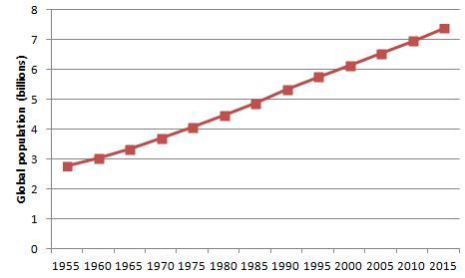

What was the global population in 2015?
Approximately 7.4 billion (your answer does not have to be exactly this)
How much has the global population increased by from 1955 to 2015?
Approximately 4.6 billion (your answer does not have to be exactly this)
Why can having more people in the world lead to deforestation?
Land is needed for people to live on and to produce the things they need (eg to farm food)
The wood is needed as fuel or as a material to build products
Why can having more people in the world lead to higher CO₂ emissions?
People use fuel that creates carbon dioxide
People also take in oxygen and breathe out carbon dioxide
Making food for people to eat almost always involves processes that release carbon dioxide into the atmosphere
How do scientists believe that CO₂ emissions contribute to climate change?
Carbon dioxide is a greenhouse gas . This means that carbon dioxide creates a barrier in the atmosphere that traps the sun’s rays close to the Earth. This heats the Earth’s overall temperature, contributing to global warming.

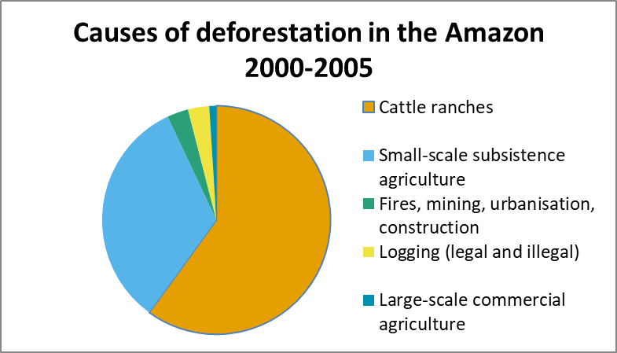
Estimate the percentage of deforestation in the Amazon that is due to cattle ranches.
Around 60%
Estimate the percentage of deforestation that is due to logging.
Below 5%
Cattle ranching means farming cows. What products come from farmed cows?
Beef, dairy products (milk, cheese, yoghurt).
What can we do to stop cattle ranching from having such a big impact on the Amazon?
Decrease the demand for products from cattle ranches (go vegetarian, eat less meat), support farmers who farm in an environmentally-thoughtful way (check the sources of meat, only buy meat farmed in a sustainable way)
Illegal logging is a small contribution to the deforestation in the Amazon. Does this mean that we should not be concerned about the effects?
The amount of land lost to illegal logging is still a huge amount, and since this logging is unregulated it could have unnecessary impact on different areas/species.

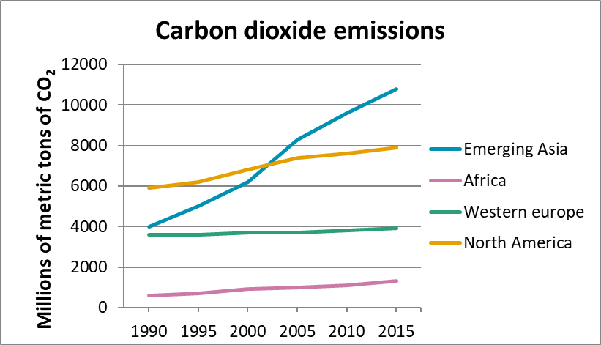

Which group of countries has the lowest CO₂ emissions? Africa
Which group of countries had the highest CO₂ emissions in 1990? North America
Which group of countries had the highest CO₂ emissions in 2015? Emerging Asia
In what year did Emerging Asian countries surpass North America in CO₂ emissions? 2001/2002
Industrialisation is a leading cause of increased CO₂ emissions. How does industrialisation create CO₂? Factories and building both require energy, which often comes from burning fossil fuels which releases CO₂ into the atmosphere.

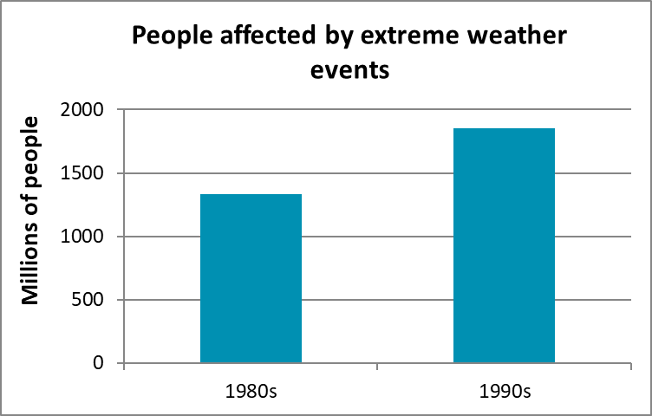
These graphs could be very misleading if they are not read carefully. In what ways are these graphs misleading? There are four different answers to this question.
Writing the units on the frequency axis may lead people to misinterpret the actual number of people affected/killed.
Using thousands on one graph and millions on the other makes it difficult to compare the two graphs.
On the first graph, the frequency starts at 540,000 people, which exaggerates the difference between the two bars on the graph.
The word “affected” could be subjective. We can assume this would include people who were injured or lost their homes, but what about those who had to take time off work to deal with the consequences, those who were evacuated but returned unharmed, those who lost friends/family/pets?
How many more people were affected by extreme weather events in the 90s compared to the 80s?
600,000,000
How many fewer people were killed by extreme weather events in the 90s compared to the 80s?
90,000
How are people affected by extreme weather events if they are not killed?
Lost family member/friends, homes damaged/destroyed, injured, displaced....
Why do you think the number of people killed decreased, while the number affected increased?
Better warning systems, better responses after events, learning from the past.
How does deforestation impact on extreme weather events?
Fewer trees means there is more CO₂ in the atmosphere, intensifying the impact of global warming. In the case of floods, trees hold a lot of water which is then released back into the system over time rather than all at once. As trees are cut down, the impact of sudden rainfall is intensified. Deforestation also destroys root systems that hold soil together. In landslides, this means more earth will slide, increasing the seriousness of the event.
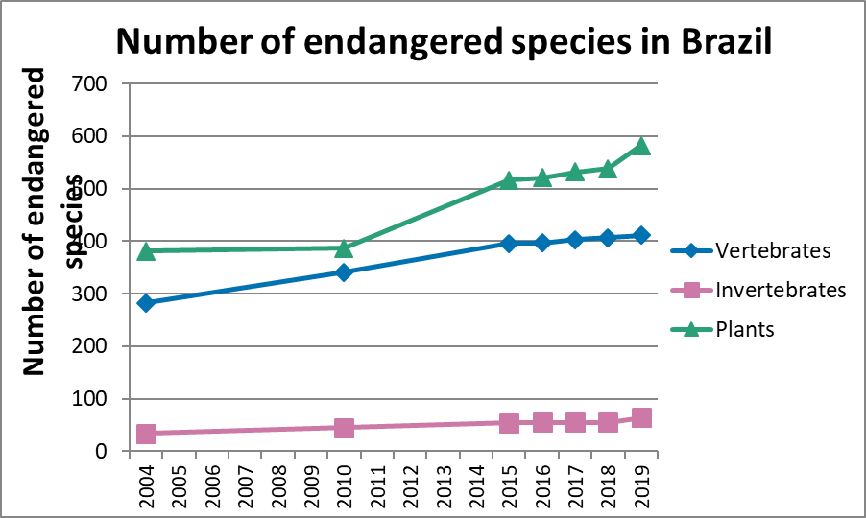
What is the difference between vertebrates and invertebrates?
These are different classifications of animal species. In vertebrates don’t have backbones (bugs, insects, spiders are all examples of invertebrates). Vertebrates have backbones (this category includes mammals, amphibians and reptiles).
What does it mean if a species is labelled as “endangered”?
There are so few examples of that species left in the wild that it could possibly become extinct.
How many animal species were classified as endangered in 2004?
316 (this is from the original data – your answer will not be exactly this as yours will come from reading the graph)
How many animal species were classified as endangered in 2019?
475 (this is from the data – your answer will not be exactly this as yours will come from reading the graph)
What is happening to the number of endangered species in Brazil?
It is increasing.
How is deforestation linked to the number of endangered species?
Trees provide food and habitat for many species – other plants, insects and bugs, birds and other animals. Removing trees has knock on effects on food chains, so many different species are harmed.
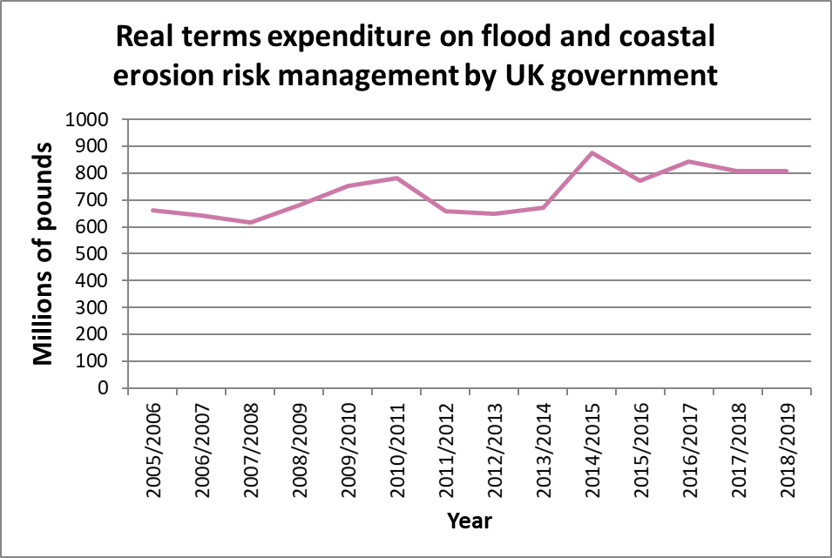

What is happening overall to the amount of money the UK government is spending on flood management? It is increasing
In which financial year did government spending on flood management peak?
2014/2015
Would you expect the government spending to continue increasing in the future?
Yes. In 2020, the country is already experiencing bad flooding and as the climate continues to change, it is likely that we will experience extreme weather events such as sudden storms more frequently.
Does deforestation have a part to play in UK flooding?
Yes. Global deforestation is contributing to climate change, which affects all countries in the world.
On a national scale, land is being repurposed from fields for building homes and services, and individually, many people are choosing to cover gardens to create patio areas and driveways. This results in more hard surfaces, so when rain falls it stays on the surface and runs into drains rather than soaking into the ground. This can overwhelm drainage systems and leads to more surface water, which is often the cause of flooding.

