Interpreting Deforestation Graphs
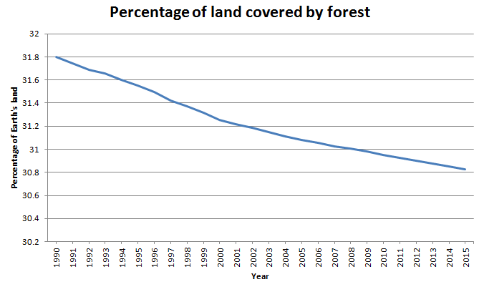
What percentage of the Earth’s land was covered with forest in 1995? ...........................
What percentage of the Earth’s land was covered with forest in 2015? ...........................
What percentage of Earth’s land was deforested between 1990 and 2015? ................................
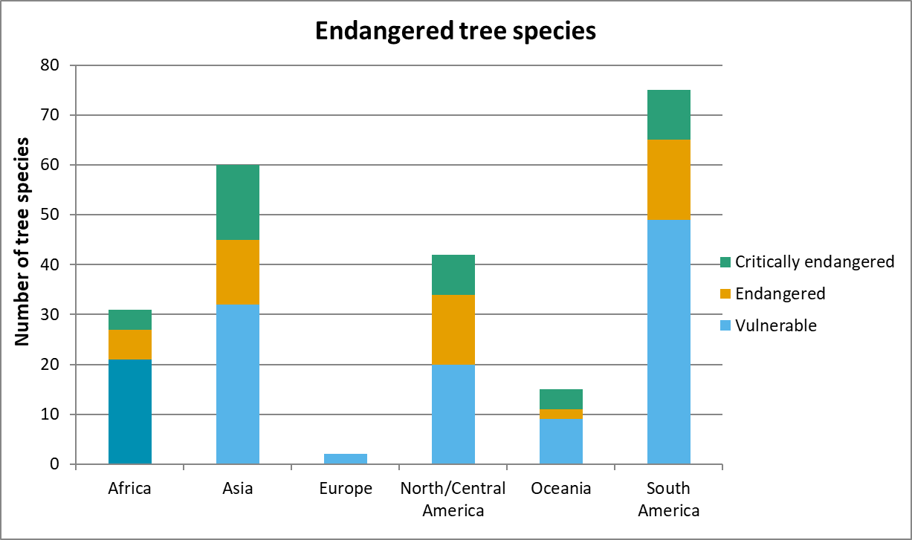
Which continent has the highest number of trees that are listed as in danger? ...........................
How many tree species are classed as endangered in Africa? ...........................
How many tree species are officially classed as critically endangered in the world? ...........................
What is causing tree species to be endangered? ....................................................................................................................................................
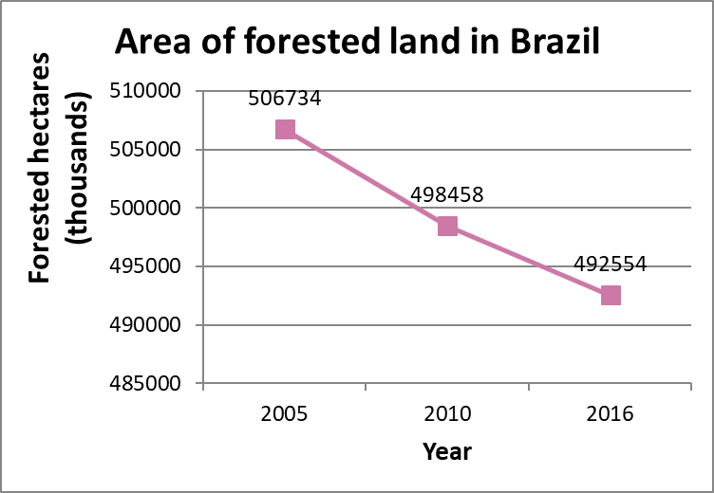

In what way could this graph mislead the viewer? (there are two main ways, plus one sneaky answer)
....................................................................................................................................................................................................................................................................................................................................................................................................................................................................................................................................................................................................................................................................................................................................................................
Brazil has a total area of 835,814,000 hectares. What percentage was forested in 2005? ...........................
What percentage of Brazil was forested in 2016? ...........................
Why is Brazil an important country when thinking about deforestation?
............................................................................................................................................................................................................................................................................................................................................................................................................................................................

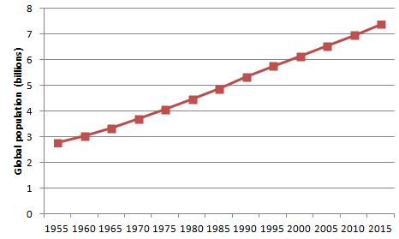

What was the global population in 2015? ...........................
How much has the global population increased by from 1955 to 2015? ...........................
Why can having more people in the world lead to deforestation?
............................................................................................................................................................................................................................................................................................................................................................................................................................................................
Why can having more people in the world lead to higher CO₂ emissions?
................................................................................................................................................................................................................................................................................................................................................................................................................................................................................................................................................................................................................
How do scientists believe that CO₂ emissions contribute to climate change?
........................................................................................................................................................................................................................................................................................................

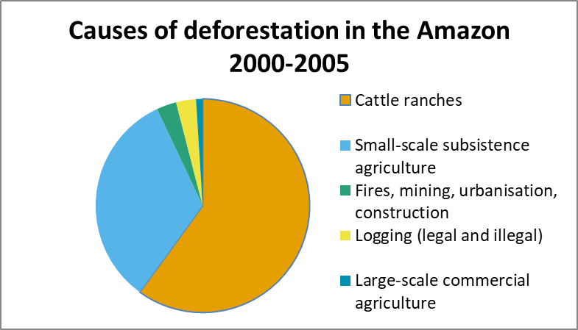
Estimate the percentage of deforestation in the Amazon that is due to cattle ranches. ...........................
Estimate the percentage of deforestation that is due to logging. ...........................
Cattle ranching means farming cows. What products come from farmed cows?
....................................................................................................................................................
What can we do to stop cattle ranching from having such a big impact on the Amazon?
........................................................................................................................................................................................................................................................................................................
Illegal logging is a small contribution to the deforestation in the Amazon. Does this mean that we should not be concerned about the effects?
........................................................................................................................................................................................................................................................................................................

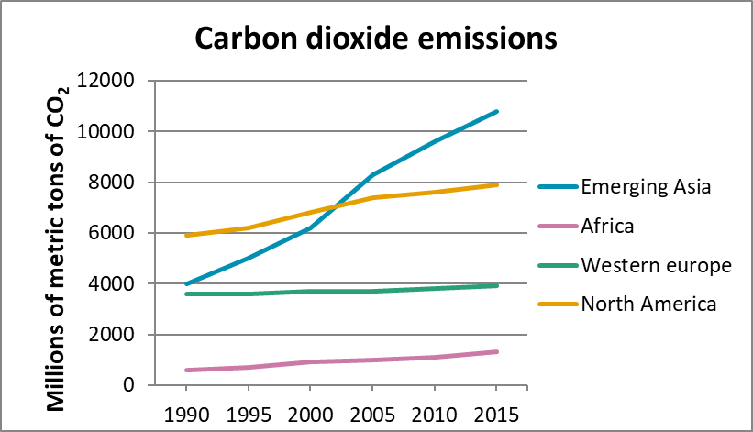

Which group of countries has the lowest CO₂ emissions? ...........................
Which group of countries had the highest CO₂ emissions in 1990? ...........................
Which group of countries had the highest CO₂ emissions in 2015? ...........................
In what year did Emerging Asian countries surpass North America in CO₂ emissions? ...........................
Industrialisation is a leading cause of increased CO₂ emissions. How does industrialisation create CO₂?
....................................................................................................................................................
....................................................................................................................................................

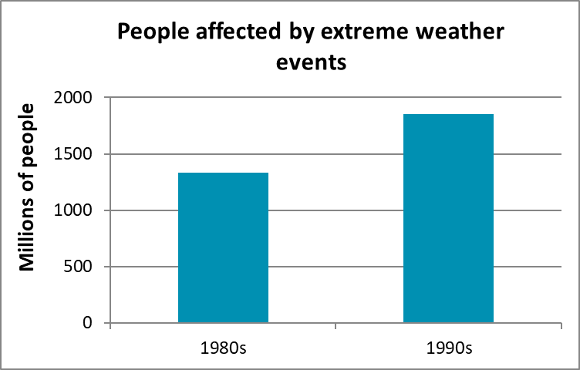

These graphs could be very misleading if they are not read carefully. In what ways are these graphs misleading? There are four different answers to this question.
...................................................................................................................................................
....................................................................................................................................................
....................................................................................................................................................
....................................................................................................................................................
....................................................................................................................................................
How many more people were affected by extreme weather events in the 90s compared to the 80s? ...........................
How many fewer people were killed by extreme weather events in the 90s compared to the 80s? ...........................
How are people affected by extreme weather events if they are not killed?
....................................................................................................................................................
....................................................................................................................................................
Why do you think the number of people killed decreased, while the number affected increased? ....................................................................................................................................................
....................................................................................................................................................
How does deforestation impact on extreme weather events? ....................................................................................................................................................
....................................................................................................................................................
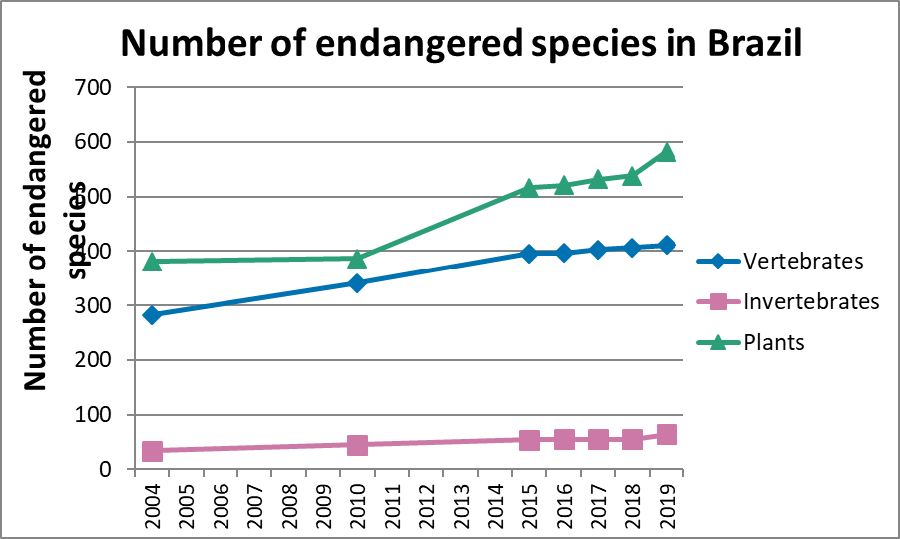
What is the difference between vertebrates and invertebrates?
........................................................................................................................................................................................................................................................................................................
What does it mean if a species is labelled as “endangered”?
....................................................................................................................................................
How many animal species were classified as endangered in 2004? ...........................
How many animal species were classified as endangered in 2019? ...........................
What is happening to the number of endangered species in Brazil? ...........................
How is deforestation linked to the number of endangered species? ....................................................................................................................................................
....................................................................................................................................................
....................................................................................................................................................

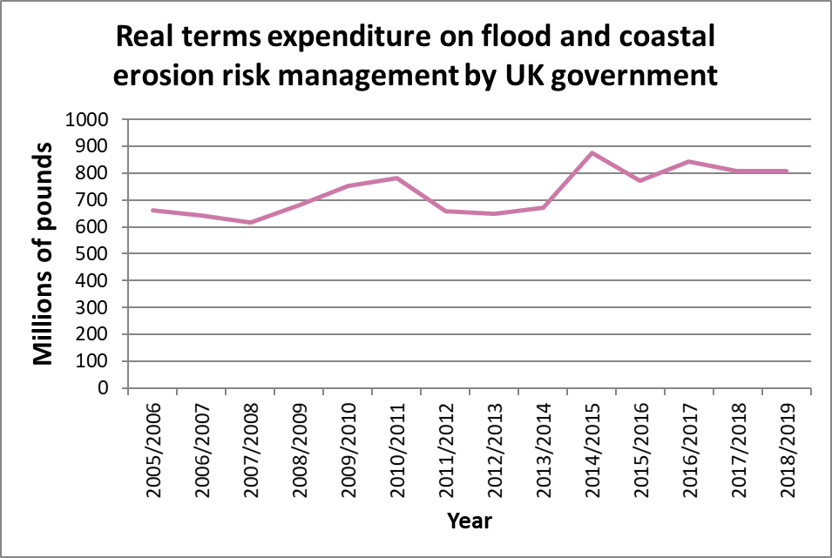

What is happening overall to the amount of money the UK government is spending on flood management?
...........................
In which financial year did government spending on flood management peak? ...........................
Would you expect the government spending to continue increasing in the future?
............................................................................................................................................................................................................................................................................................................................................................................................................................................................
Does deforestation have a part to play in UK flooding?
............................................................................................................................................................................................................................................................................................................................................................................................................................................................

