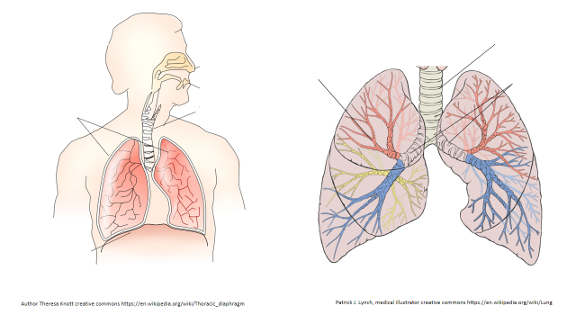
Label the diagram to show the parts of the respiratory (breathing) system.

