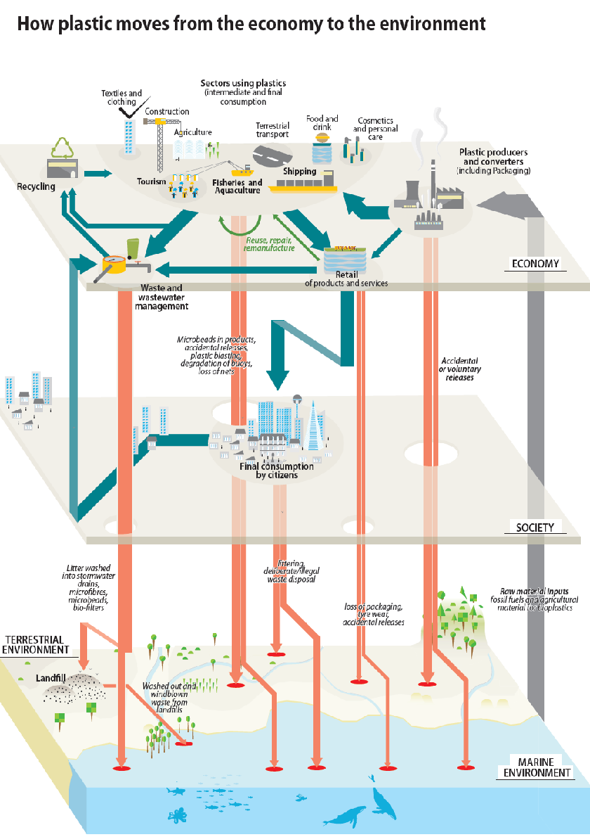
Plastic pollution and the economy.
Your teacher may give your group a larger image to work from.
Study the diagram which shows the life of plastic.
- The economy is the way in which a country makes money. Name three parts of the economy that use plastic.

- What does the thickness of the arrows indicate?

- Why are some arrows blue and some arrows pink?

- Because a lot of waste is produced unintentionally it can be difficult to control. Suggest a way, these losses could be reduced.

